***Experiment No. __***

Q_ -> Wap to make a single page Quiz App ??

Sol -

***Main Activity.Xml***

***<RelativeLayout xmlns:android="http://schemas.android.com/apk/res/android"***

***xmlns:tools="http://schemas.android.com/tools"***

***android:layout_width="match_parent"***

***android:layout_height="match_parent"***

***android:paddingBottom="@dimen/activity_vertical_margin"***

***android:paddingLeft="@dimen/activity_horizontal_margin"***

***android:paddingRight="@dimen/activity_horizontal_margin"***

***android:paddingTop="@dimen/activity_vertical_margin"***

***tools:context=".MainActivity" >***

***<TextView***

***android:id="@+id/textView1"***

***android:layout_width="wrap_content"***

***android:layout_height="wrap_content"***

***android:text="Q1 - Who is the Prime Minister of India ??" />***

***<Button***

***android:id="@+id/btnSubmit"***

***android:layout_width="wrap_content"***

***android:layout_height="wrap_content"***

***android:layout_alignParentBottom="true"***

***android:layout_centerHorizontal="true"***

***android:layout_marginBottom="42dp"***

***android:text="Submit" />***

***<RadioGroup***

***android:id="@+id/rgOpinion"***

***android:layout_width="wrap_content"***

***android:layout_height="wrap_content"***

***android:layout_alignParentLeft="true"***

***android:layout_alignParentRight="true"***

***android:layout_below="@+id/textView1"***

***android:layout_marginTop="25dp" >***

***<RadioButton***

***android:id="@+id/radio0"***

***android:layout_width="wrap_content"***

***android:layout_height="wrap_content"***

***android:text="Rahul Gandhi" />***

***<RadioButton***

***android:id="@+id/radio1"***

***android:layout_width="wrap_content"***

***android:layout_height="wrap_content"***

***android:text="Tulsi" />***

***<RadioButton***

***android:id="@+id/radio2"***

***android:layout_width="wrap_content"***

***android:layout_height="wrap_content"***

***android:text="Narendra Modi" />***

***<RadioButton***

***android:id="@+id/radio3"***

***android:layout_width="wrap_content"***

***android:layout_height="wrap_content"***

***android:text="Sharukh Khan" />***

***</RadioGroup>***

***</RelativeLayout>***

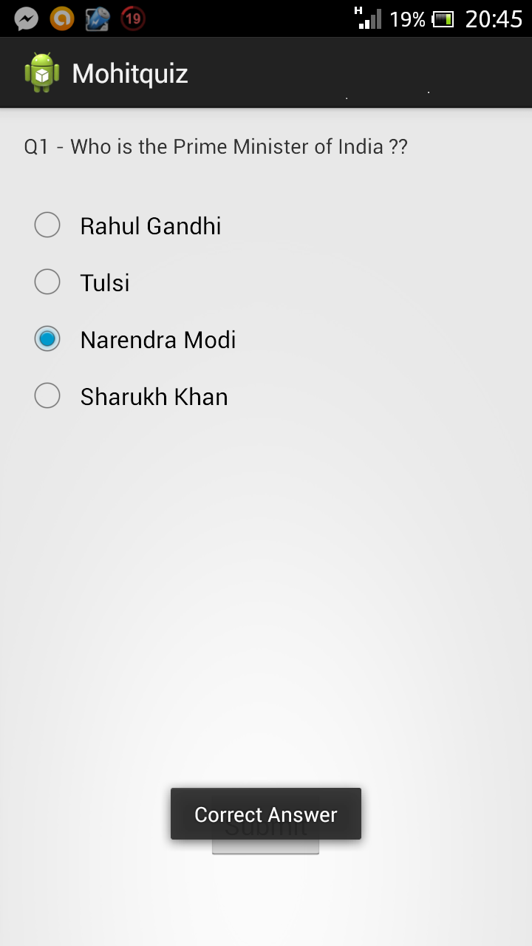

**Main.java**

***package com.example.mohitquiz;***

***import android.os.Bundle;***

***import android.app.Activity;***

***import android.view.Menu;***

***import android.view.View;***

***import android.widget.Button;***

***import android.widget.RadioButton;***

***import android.widget.RadioGroup;***

***import android.widget.Toast;***

***import android.view.View.OnClickListener;***

***public class MainActivity extends Activity implements OnClickListener {***

***RadioGroup rg;***

***Button b;***

***@Override***

***protected void onCreate(Bundle savedInstanceState) {***

***super.onCreate(savedInstanceState);***

***setContentView(R.layout.activity_main);***

***rg = (RadioGroup) findViewById(R.id.rgOpinion);***

***b = (Button) findViewById(R.id.btnSubmit);***

***b.setOnClickListener(this);***

***}***

***@Override***

***public boolean onCreateOptionsMenu(Menu menu) {***

***getMenuInflater().inflate(R.menu.main, menu);***

***return true;***

***}***

***@Override***

***public void onClick(View view) {***

***RadioButton rb = (RadioButton) findViewById(rg.getCheckedRadioButtonId());***

***String s = rb.getText().toString();***

***if(s.equals("Narendra Modi")) {***

***Toast.makeText(this, "Correct Answer", Toast.LENGTH_LONG).show();***

***}***

***else***

***Toast.makeText(this, "Incorrect Answer", Toast.LENGTH_LONG).show();***

***}***

***}***